**CS428/538 Course Project 4**

**Secure QR Code**

**Project Description**



Currently, QR code been widely adopted by various applications, since it can be used to efficiently and conveniently store many types of data, including, URLs, Images, Plain Text, V-cards, etc. However, the adoption of QR codes also opens a door for malicious entities to steal private information from QR code users. On one hand, QR codes frequently appear on today’s utility bills, invoices, receipts, which always contain sensitive information, such as identity information, financial information, healthcare information. If the QR code is not protected appropriately, malicious entities can scan it and obtain information inside of it. On the other hand, malicious entities may also generate fake QR codes and try to confuse users to enter their personal information after scanning the fake QR codes.

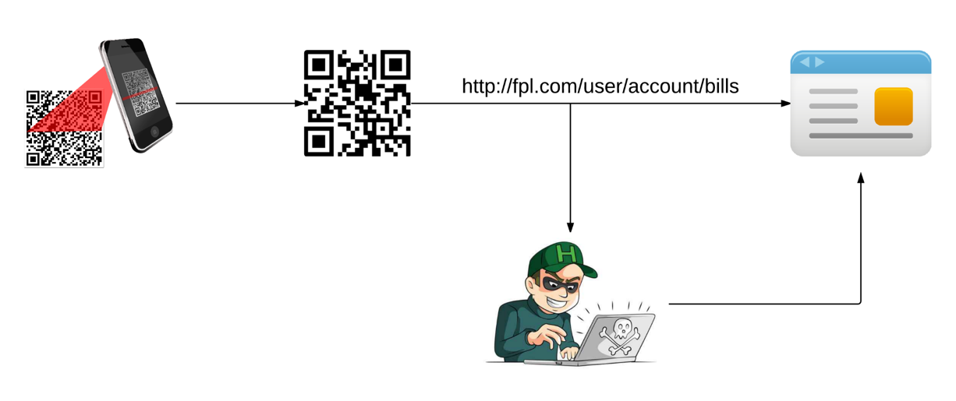

The goal of this project is therefore to find a cryptographic mechanism to achieve a secure QR code design. The design should use appropriate public encryption schemes to protect user privacy information. In addition, the design shall enable QR code scanners to verify the identity of senders.

**Project Tasks**

Design, implement, and evaluate a secure QR code design that addresses the issues presented by the scenario outlined above. Issues that *must* be addressed are:

• Appropriately choice of cryptographic primitives to ensure the goals outlined above.

• Threat model; you should explicitly state what threats your system has been designed to handle.

• Security: Make sure that your system protects against the security issues raised in the threat model, and clearly document the threats that you do not protect against.

• Implement your design or tools.